GRANARD MUNICIPAL DISTRICT

Corporate Affairs,
Aras an Chontae,
LONGFOIRT.

20th February 2018.

To: Each Member of Granard Municipal District.

Dear Member,

You are requested to attend Meeting of Granard Municipal District to be held in
Granard Community Library at 4.00 p.m. on Tuesday, 27th February 2018 to transact business, as set out on the Agenda hereunder.

Agenda.

1. To consider and approve Schedule of Granard Municipal District Works - Report to follow.

Yours sincerely,

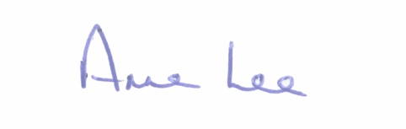

_______________
Anne Lee,
Meetings Administrator.

